Github Link: <https://github.com/oguzya/Top5-Workshop>

**Names:**  
**UI team:** Emily Altland, Shawal Khalid, Jeffrey Smith, Swetha Rajeev  
**Software team:** Mary Kate McGranahan, Mehmet Oguz Yardimci  
**Database team:** Min, Francis

**Instructions:**

You will be assigned to a larger group (I or II) in class, and a sub-group based on the different components of software design (User Interface, Software Component, Database). Complete the following in your group:

1. Complete design activities for your corresponding group (i.e.: prototype, storyboard, etc. for UI; class diagrams for SC; and ER diagrams for DB) to design components of the Top Five system. You will need to collaborate with the larger group to inform your sub-group’s design.
2. Each group will give a short presentation of their design to the class.
3. Add everything you complete in-class to a GitHub repo. [Group]
4. Submit response to the following questions on Canvas: [Individual]
   1. How are humans involved in the design phase for software development?
   2. What challenges did you encounter in the design activities?
   3. As discussed, most developers do not use the design activities described in the lecture to design software systems. Based on your experiences in this workshop, are these activities necessary or unnecessary for designing software? Why or why not?

**User Interface Group:**

How are humans involved in the design phase for software development?

Humans are crucial in the User Interface design phase. AI tools have yet to catch up with human designers in UI designs. There are a few very important features to a user interface that the designs must include; ease of use, ability to reach every feature in the software necessary for the user, and meetings the minimum requirements for the software deliverable. Current Ai automation tools for User Interface design often lack important details in one of these categories since the model doesn’t understand the whole concept of the software and the AI model isn't human so it doesn't understand what making a design usable for humans.

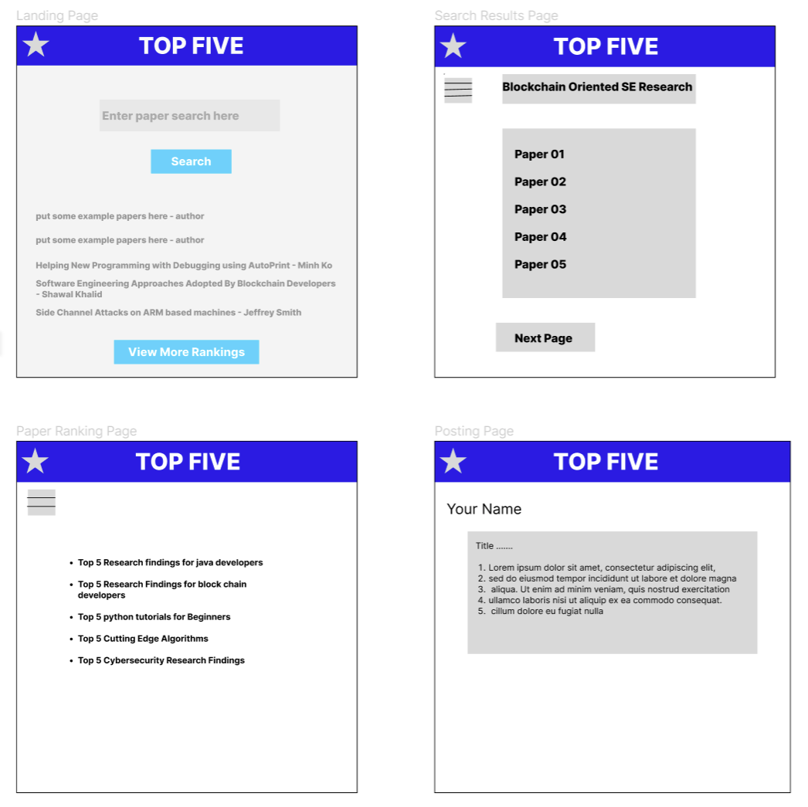

**Software Component:**

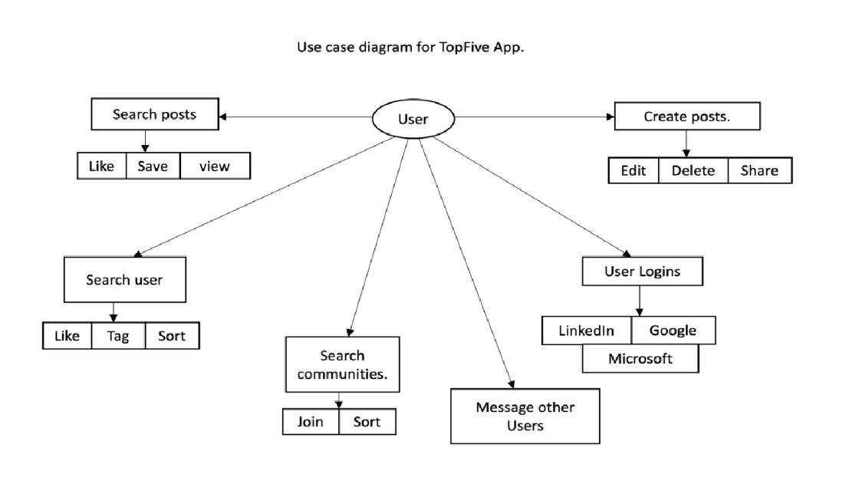

Class Diagram: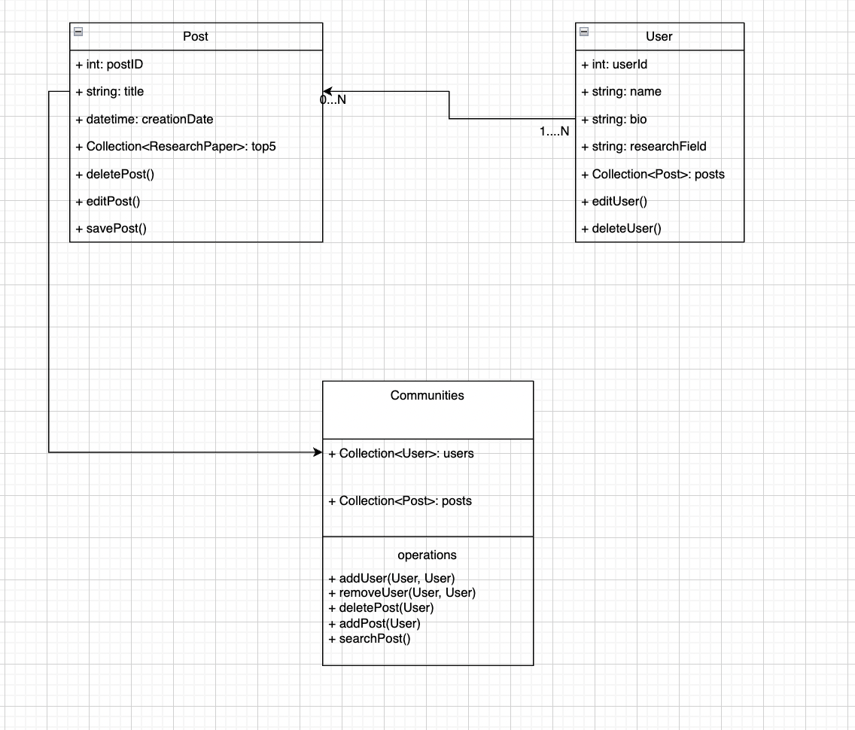

**Database Group:**

E/R Diagram

